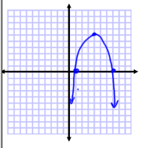  Write an equation using the roots that could model the graph below. | 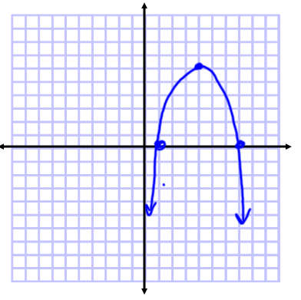  Write an equation using the roots that could model the graph below.
Find the discriminant for the equation below. Then, state how many and what type of solutions the equation will have.  $$y=5x^{2}+ 20x+3$$ | Find the discriminant for the equation below. Then, state how many and what type of solutions the equation will have.  $$y=-2x^{2}+6x-8$$
Will the graph pictured have a positive, negative, or zero discriminant? Explain your answer. | 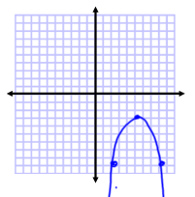  Will the graph pictured have a positive, negative, or zero discriminant? Explain your answer.
An equation has one real solution. Will the discriminant of the equation be positive, negative, or zero? Explain your answer. | An equation has solutions at 3 and 7. Will the discriminant of the equation be positive, negative, or zero? Explain your answer.

